Name – Prerak M. Parekh
Second Year Computers
Web Technology Lab

Aim – To develope a product adding page using jQuery library

Theory -

jQuery is a lightweight, "write less, do more", JavaScript library.
The purpose of jQuery is to make it much easier to use JavaScript on your website.
jQuery takes a lot of common tasks that require many lines of JavaScript code to accomplish, and wraps them into methods that you can call with a single line of code.
jQuery also simplifies a lot of the complicated things from JavaScript, like AJAX calls and DOM manipulation.
The jQuery library contains the following features:
- HTML/DOM manipulation
- CSS manipulation
- HTML event methods
- Effects and animations
- AJAX
- Utilities
There are lots of other JavaScript libraries out there, but jQuery is probably the most popular, and also the most extendable.

The jQuery team knows all about cross-browser issues, and they have written this knowledge into the jQuery library. jQuery will run exactly the same in all major browsers.

In addition jQuery has plugin for almost each and every thing required or done in javascript.

Code -

html code -

<!DOCTYPE html>
<html lang="en">
<head>
<meta charset="UTF-8">
<meta name="viewport" content="width=device-width, initial-scale=1.0">
<title>jQuery</title>
<script src="/home/ubuntu/Desktop/jquery-3.4.1.js"></script>
<script src="jquery.js"></script>
<link rel="stylesheet" href="jquery.css">
</head>
<body>
<p>Please upload your product over here to capture the world</p>
<form>
<input type="text" name="Seller" id="Seller">
<label for="Seller" style="display:none">Seller Name</label><br><br>
<input type="text" name="ProductName" id="ProductName">
<label for="ProductName" style="display:none">Product Name</label><br><br>
<input type="text" name="Price" id="Price">
<label for="Price" style="display:none">Price</label><br><br>
<input type="password" name="Password" id="Password">
<label for="Password" style="display:none">Password</label><br>
<div><br></div><br>
<input type="checkbox" id="Electronics" value="Electronics">Electronics<br>
<input type="checkbox" id="Fashion" value="Fashion">Fashion<br>
<input type="checkbox" id="Home Appliances" value="Home Appliances">Home Appliances<br>
<input type="checkbox" id="Toys" value="Toys">Toys<br>
<input type="checkbox" id="Home Appliances" value="Miscellenous">Miscellenous<br><br>
<textarea rows="6" cols="100" name="description" id="description" placeholder="" onfocus="this.placeholder = 'Product Description'" style="display: inline-block;"></textarea><br><br>
<h3>Please upload a picture strictly having a resolution of more then 200px</h3><br>
<input type="file"><br><br>
<button type="button" id="done">Submit</button>
</form>
</body>
</html>

Css code -

body{
background-color: powderblue;
}

JavaScript Code -

$(document).ready(function(){
$("#descriptionToggle").click(function(){
$("#description").toggle();
$(this).find('img').toggle("slow");
});
$("input:first").focus();
$("input:first").css("background-color", "cadetblue");
$('label[for="Seller"]').show();
$("input, textarea").focus(function(){
$(this).css("background-color", "cadetblue");
$('label[for="'+this.id+'"]').fadeTo("fast", 1);
$(this).attr("placeholder", $(this).attr("rel"));
$(this).removeAttr("rel");
});
$("#Password").focus(function(){
$("div").show();
});
$("*").blur(function(){
$(this).css("background-color", "white");
$('label[for="'+this.id+'"]').fadeTo("fast", 0);
$(this).attr("rel", $(this).attr("placeholder"));
$(this).removeAttr("placeholder");
});
$("#Password").bind('keydown', function(e){
$("div").html("You presssed: " + e.which);
});
$("#Password").blur(function(){
$("div").html("<br>");
});
var words = $( "p" ).text().split( /\s+/ );
var text = words.join( "</span> <span>" );
$( "p" ).first().html( "<span>" + text + "</span>" );
$( "span" ).on( "click", function() {
$( this ).css( "background-color", "red" );
});
$('p').mouseenter(function() {
$('p').css("background-color", "#AAAAAA");
});
$('p').mouseout(function() {
$('p').css("background-color", "white");
});
});

Output -

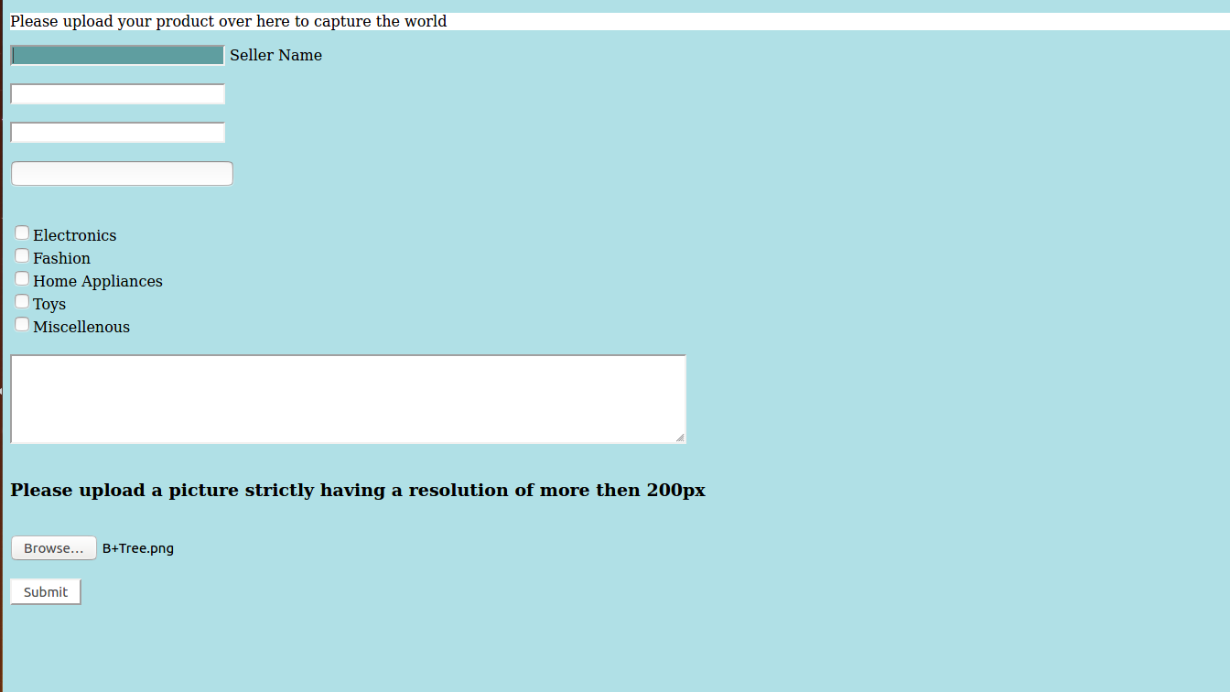

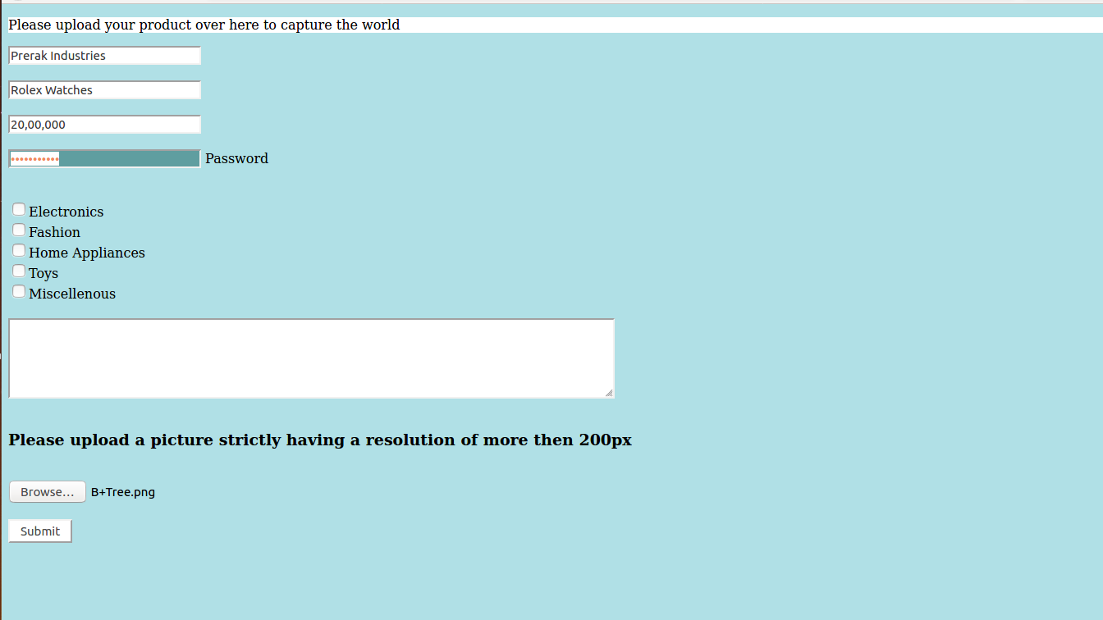
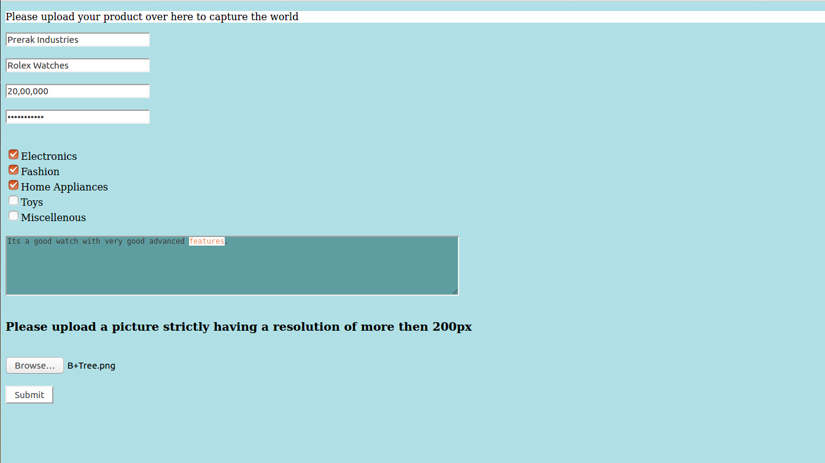

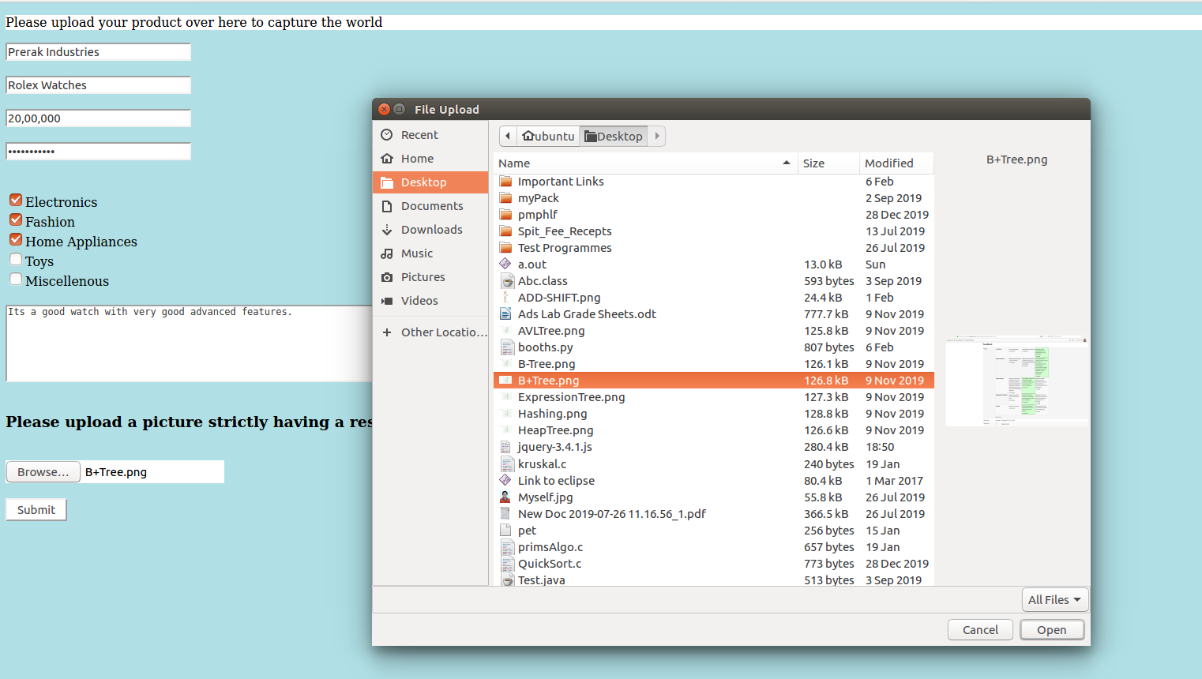
Conclusion -

After completing the above experiment, I have understood the richness of jQuery and its application in easily making responsive web pages with minimal javacript code.
Also came to know about the callback function which helps to prevent error and also allows smooth functioning of the animation.

